AWS EC2 task

S.no | Task | Main concept
1: | Amazon Linux 2 + Apache using User Data | User Data
2: | Ubuntu + Nginx using User Data | User Data
3: | Windows Server + Tomcat | Windows EC2
4: | Snapshot of Task 1 | EBS Snapshot
5: | Passwordless authentication for Task 2 | SSH key authentication
6: | Launch EC2 using Spot | Spot Instance
7: | Enable termination protection on Task 2 | Termination protection
8: | Launch EC2 using AWS CLI | AWS CLI

1: Launch one EC2 using Amazon Linux 2 image and add a script in user data to install Apache.
Go to EC2 → Instances → Launch instance.
- Name: Task1-Apache
- AMI: Select Amazon Linux 2
- Instance type: Choose the required small/free-tier-eligible type.
- Key pair: Select your existing key pair.
- Network settings:
  - ✅ Allow SSH traffic
  - ✅ Allow HTTP traffic from the internet
- Scroll to Advanced details.
- Find User data.
- Paste:
#!/bin/bash
yum update -y
yum install -y httpd
systemctl start httpd
systemctl enable httpd
- Click Launch instance.
- Wait for Running.
- Copy the Public IPv4 address.
- Open:
http:// 107.21.197.125
- If the Apache page opens → ✅ Task 1 completed.
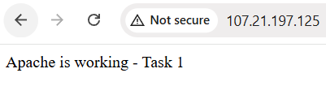
2: Launch one EC2 using Ubuntu image and add a script in user data to install Nginx.

. Go to EC2 → Instances → Launch instance.
2. Name: Ubuntu-Nginx
3. AMI: Select Ubuntu Server 26.04 LTS
4. Instance type: Choose the required small/free-tier-eligible type.
5. Key pair: Select your existing key pair.
6. Network settings:
- ✅ Allow SSH traffic
- ✅ Allow HTTP traffic from the internet
- ❌ HTTPS traffic — not required for this task
7. Scroll to Advanced details.
8. Find User data.
9. Paste:
#!/bin/bash
apt update -y
apt install -y nginx
systemctl start nginx
systemctl enable nginx
10. Click Launch instance.
11. Wait for Running.
12. Copy the Public IPv4 address.
13. Open:
http://100.31.67.254
Expected result: The Welcome to nginx! page should appear.

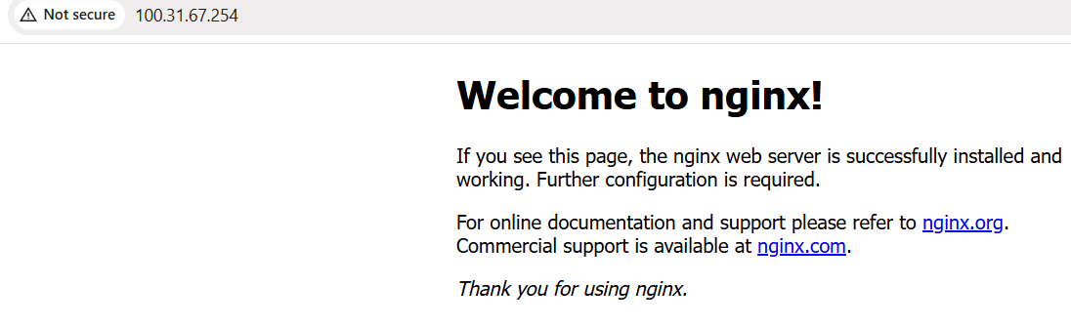
3: Launch one Windows server and install Tomcat on Windows

- Task

AWS / EC2
- Launch Windows EC2 Server
- Get Encrypted Password
- Decrypt Password Using .pem Key
- Connect Using Remote Desktop (mstsc)
Inside Windows EC2
- Install Java JDK 17
- Download Tomcat 10.1.59
- Extract Tomcat
- Start Tomcat
- Verify Tomcat on Port 8080

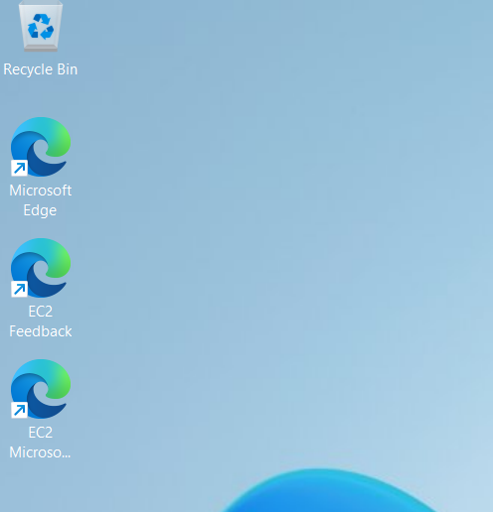

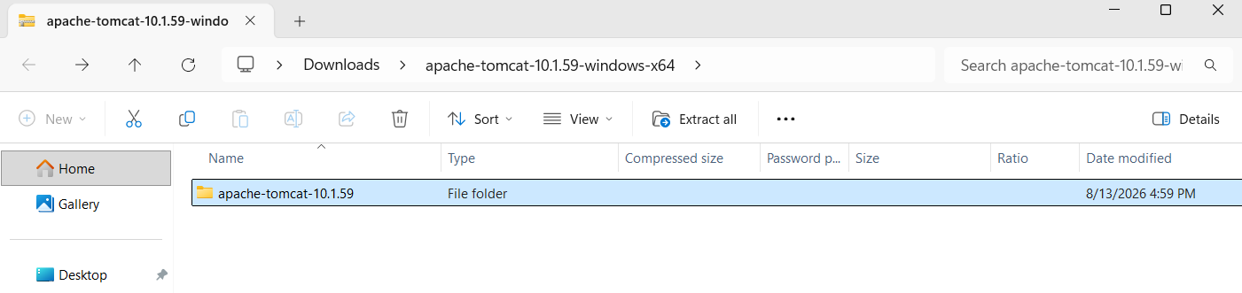
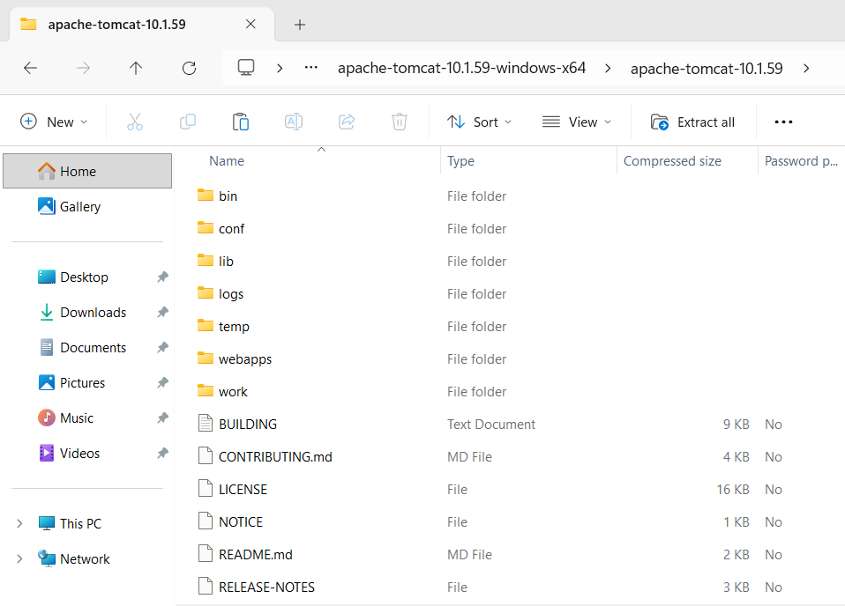
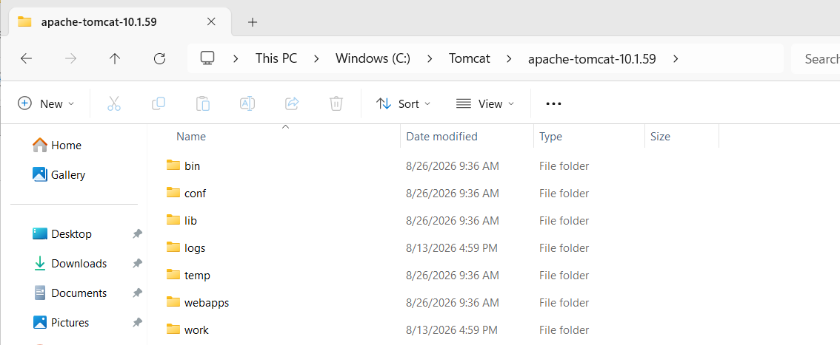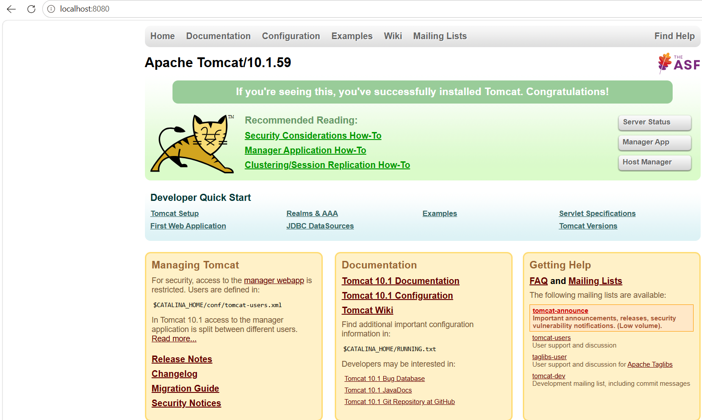
Successfully install Tomcat on Windows

4: Take a snapshot of the instance created in Task 1.
Steps:
- Open AWS Console → EC2 → Instances.
- Select the Windows-Tomcat instance created in Task 1.
- Go to the Storage tab.
- Find the Root device /dev/sda1.
- Note the attached EBS Volume ID (vol-xxxxxxxx).
- In the left menu, go to Elastic Block Store → Snapshots.
- Click Create snapshot.
- Select Resource type → Volume.
- Select the EBS volume attached to /dev/sda1.
- Enter a description:
Task 4 - Windows Tomcat Server Snapshot
- Click Create snapshot.
- Verify the snapshot appears under Snapshots.
- Wait until Snapshot status changes from Pending to Completed.
Result
Snapshot created successfully.
Snapshot ID: snap-01cc2e044860da37f ✅

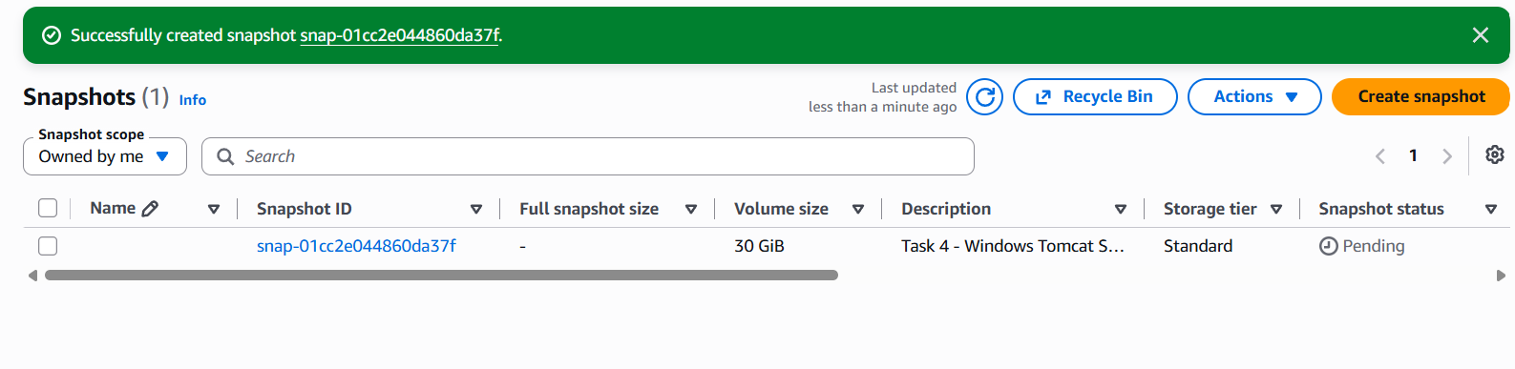
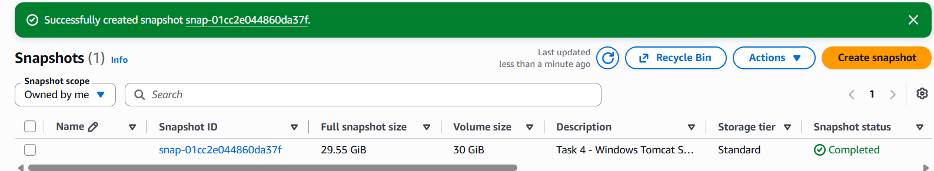
Result: Snapshot successfully created and completed. ✅

5: Assign passwordless authentication for the EC2 created in Task 2.
- notes for your task
- Launch/select the Ubuntu-Nginx EC2 instance.
- Verify the assigned key pair is khan.
- Download/use the khan.pem private key.
- Open Git Bash on Windows.
- Connect using:
- ssh -i "khan.pem" ubuntu@ec2-107-20-123-13.compute-1.amazonaws.comSuccessfully logged in without entering a password.
Result: Passwordless SSH authentication successfully configured and verified. ✅
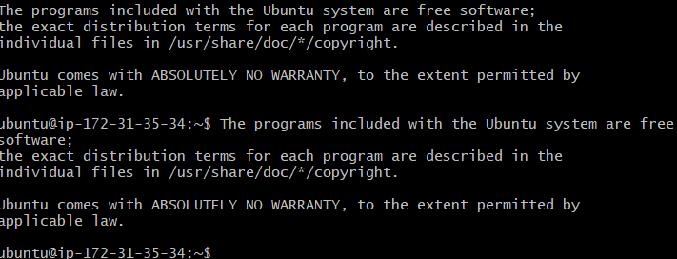
6: Launch any EC2 using the spot purchasing option.

- Open AWS Console → EC2 → Instances.
- Click Launch instances.
- Enter an instance name, for example Spot-Instance.
- Select an AMI such as Amazon linux or Ubuntu
- Select an Instance type, such as t3.micro.
- Select an existing Key pair.
- Scroll to Advanced details.
- Find Purchasing option.
- Select Spot instances.
- Leave Capacity reservation, Tenancy, and RAM disk ID as default.
- Click Launch instance.
- Go to EC2 → Instances and verify the new instance is running.

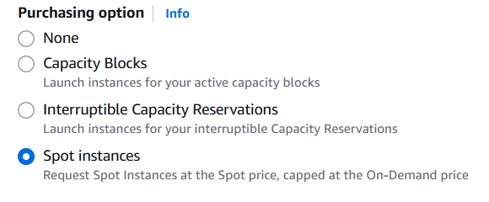

Result: EC2 instance successfully launched using Spot purchasing option. ✅

7: Enable termination policy on the EC2 created in Task 2.

Open EC2 → Instances.
Select Ubuntu-Nginx.
Click Actions.
Select Instance settings.
Click Change termination protection.
Select Enable.
Click Save.
Verify termination protection is enabled.
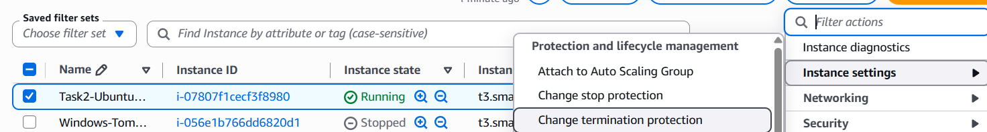
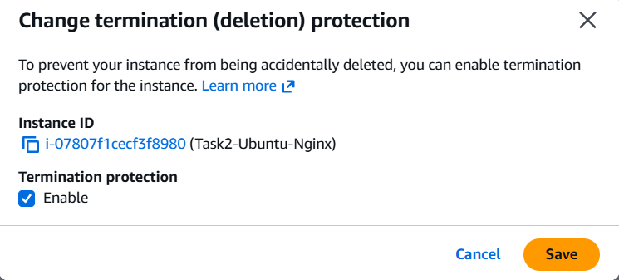
Result: Termination protection successfully enabled on the Task 2 EC2 instance. ✅

8: Launch one EC2 using AWS CLI.

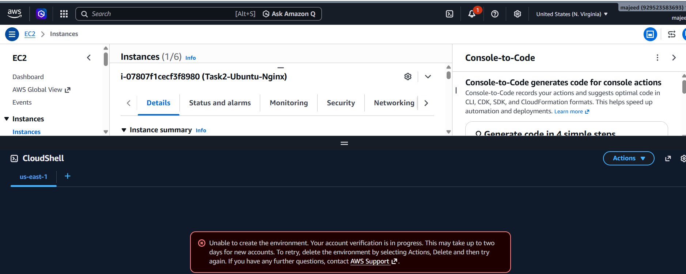
run AWS CLI from your Windows PC instead.
Install/check AWS CLI on your Windows PC.
Configure AWS CLI with your AWS credentials.
Get an Amazon Linux AMI ID.
Run aws ec2 run-instances.
Verify the new EC2 instance.

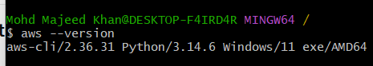

Commands used for Task 8:
- aws ec2 describe-key-pairs \ --query 'KeyPairs[*].KeyName' \ --output table
- then aws ec2 describe-images \ --owners amazon \ --filters "Name=name,Values=al2023-ami-*-x86_64" \ "Name=state,Values=available" \ --query 'Images | sort_by(@, &CreationDate) | [-1].[ImageId,Name]' \ --output table

- aws ec2 run-instances \ --image-id ami-0fe74bfcad4fd6bd2 \ --instance-type t3.small \ --key-name khan \ --count 1

- Then verified it with: aws ec2 describe-instances \ --query 'Reservations[].Instances[].[InstanceId,State.Name,InstanceType,PublicIpAddress]' \ --output table

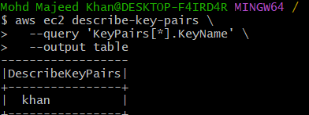
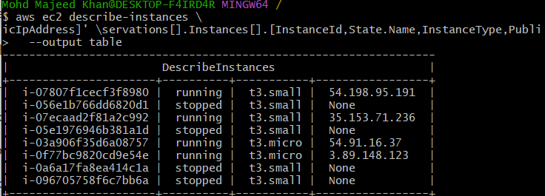
Final Status
✅ AWS CLI authentication verified
✅ Key pair identified
✅ Amazon Linux 2023 AMI identified
✅ One t3.small EC2 instance launched
✅ Instance verified as running
Task 8 — Completed successfully.

